From : Announcing a visit from Jen Bryant, award-winning author of several historical novels and picture book biographies. Jen Bryant will be visiting the school on . We are offering you (and your child) a chance to pre-order one or more books to be autographed by Jen. See the summaries and prices below to make your choice. In the personalization column, please print the name of the person the book is “to.” Cash or check payments (made out to ) and order form are due . Don’t miss this great opportunity!

CHILD’S NAME: TEACHER:
PARENT’S NAME: PHONE NUMBER:
TOTAL AMOUNT PAID:
Book | Quantity |  | Personalization
Above the Rim: How Elgin Baylor Changed Basketball $  A poetic, exquisitely illustrated telling of the life of an underrecognized athlete and a celebration of standing up for what is right. Hall-of-famer Elgin Baylor was one of basketball’s all-time-greatest players. One of the first professional African American players, he inspired others on and off the court. But when traveling for away games, many hotels and restaurants turned Elgin away because he was black. One night, Elgin had enough and staged a one-man protest that captured the attention of the press, the public, and the NBA. |  | 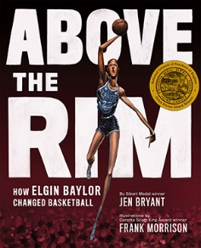
Feed Your Mind: A Story of August Wilson $  August Wilson (1945–2005) was a two-time Pulitzer Prize-winning playwright who had a particular talent for capturing the authentic, everyday voice of black Americans. Like many of his plays, Feed Your Mind is told in two acts, revealing how Wilson grew up to be one of the most influential American playwrights. |  | 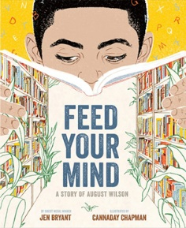
Six Dots: A Story of Young Louis Braille $  This picture book biography explores the young life of inventor Louis Braille from a unique perspective—his own. By imagining what it felt like to lose his sight in early childhood, to struggle for the right to be educated, and to invent—despite many obstacles—a new system of reading and writing that is still in use today, the author takes us inside the mind and heart of Louis Braille. Excellent for STEM. |  | 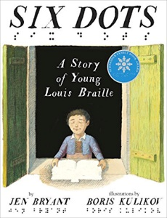

Book | Quantity |  | Personalization
The Right Word: Roget & His Thesaurus $  For shy young Peter Mark Roget, books were the best companions – and it wasn’t long before Peter began writing his own book. But he didn’t write stories; he wrote lists. Peter took his love for words and turned it to organizing ideas and finding exactly the right word to express just what he thought. His lists grew and grew, eventually turning into one of the most important reference books of all time. |  | 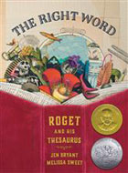
A Splash of Red: The Life & Art of Horace Pippin $  As a child in the late 1800s, Horace Pippin loved to draw. Even during W.W.I, Horace filled his notebooks with drawings from the trenches . . . until he was shot. Upon his return home, Horace couldn’t lift his right arm, and couldn't make any art. Slowly, with lots of practice, he regained use of his arm, and was able to paint. Soon, people—including the famous painter N. C. Wyeth—started noticing Horace's art, and before long, his paintings were displayed in galleries and museums across the country. |  | 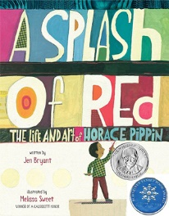
A River of Words: The Story of William Carlos Williams $  When he wrote poems, he felt as free as the Passaic River as it rushed to the falls. Willie’s notebooks filled up, one after another. Willie’s words gave him freedom and peace, but he also knew he needed to earn a living. So he went off to medical school and became a doctor -- one of the busiest men in town! Yet he never stopped writing poetry. |  | 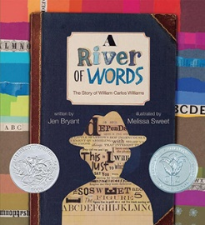
Georgia’s Bones $  Growing up on a Wisconsin farm, Georgia O’Keeffe began gathering all sorts of objects — sticks and stones, flowers and bones. Although she was teased for her interest in unique shapes and sizes, young Georgia declared: “Someday, I’m going to be an artist” — and that is exactly what she became. |  | 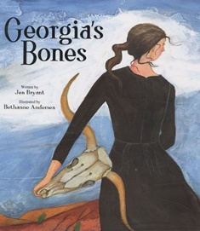

Book | Quantity |  | Personalization
Pieces of Georgia $  Like her mother, Georgia McCoy is an artist, but her dad looks away whenever he sees her with a sketchbook. Sometimes it’s hard to remember what it was like when her mother was still alive . . . when they were a family . . . when they were happy. But then a few days after her 13th birthday, Georgia receives an unexpected gift–a strange, formal letter, all typed up and signed anonymous–granting her free admission to the Brandywine River Museum for a whole year. And things begin to change. |  | 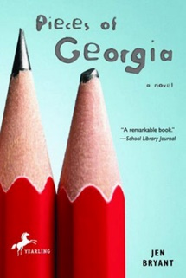
The Trial $  In a compelling, immediate voice, 12-year-old Katie Leigh Flynn takes us inside the courtroom of the most widely publicized criminal case of the 20th century: the kidnapping and murder of Charles Lindbergh’s baby son. And in doing so, she reveals the real-life figures of the trial—the accused, the lawyers, the grieving parents—and the many faces of justice. |  | 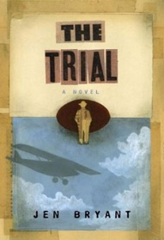
Kaleidoscope Eyes $  When Lyza helps her dad clean out her late grandfather’s house, a mysterious surprise brightens the sad task. In Gramps’s dusty attic, Lyza discovers three maps, carefully folded and stacked, bound by a single rubber band. On top, an envelope says “For Lyza ONLY.” What could this possibly be? It takes the help of her two best friends, Malcolm and Carolann, to figure out that the maps reveal three possible spots in their own New Jersey town where the Captain Kidd, seventeenth-century pirate, may have buried a treasure. Can three thirteen-year-olds actually conduct a secret treasure hunt? And what will they find? |  | 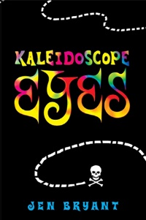
Ringside 1925 $  The year is 1925, and the students of Dayton, Tennessee, are ready for a summer of fishing, swimming, and drinking root beer floats at Robinson’s Drugstore. But when their science teacher, J. T. Scopes, is arrested for having taught Darwin’s theory of evolution, it seems it won’t be an ordinary summer in Dayton. As Scopes’s trial proceeds, the small town pulses with energy and is faced with astonishing nationwide publicity. Suddenly surrounded by fascinating people and new ideas, Jimmy Lee, Pete, Marybeth, and Willy are thrilled. But amidst the excitement and circus-like atmosphere is a threatening sense of tension—not only in the courtroom, but among even the strongest of friends. |  | 